Essentials of Computer Science and Career Skills Assignment 2

Student Name: Raghav Gupta
Course: BCA (AI & DS) Section A
Date: 14/11/2025

1. Introduction
This assignment focuses on developing foundational skills in working with the Linux operating system through practical implementation. The process involves installing Linux using WSL, executing essential shell commands, creating automation scripts, and organizing outputs within a GitHub repository. Resolving installation and configuration issues also strengthened understanding of Linux system behaviour and command-line operations.
The assignment contributes to a clearer understanding of Linux, its command-line interface, and its relevance in areas such as system administration, DevOps, and software development. The following sections outline the completed tasks along with the corresponding screenshots.

2. Linux Installation (WSL – Ubuntu)
Method Used: Windows Subsystem for Linux (Ubuntu 22.04.5 LTS)
Steps:
- Installed Ubuntu from the Microsoft Store.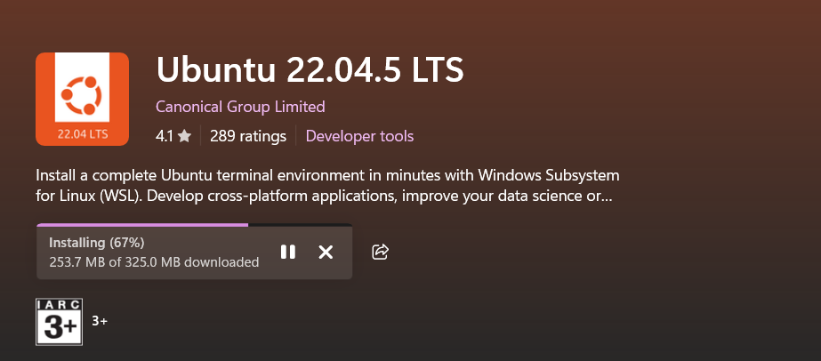
- Launched it and set up a UNIX username and password.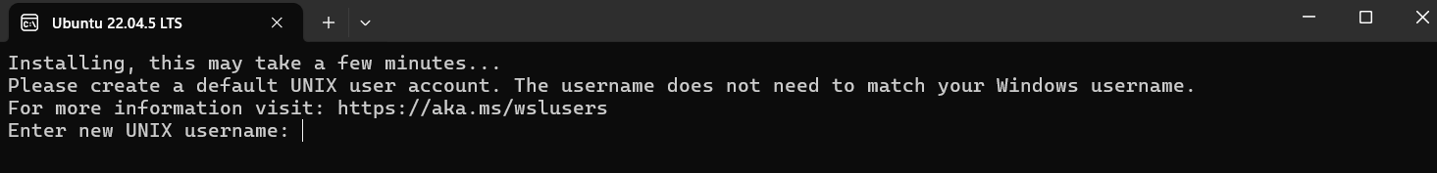

3. Shell Commands
Different Linux commands for navigation, file handling, permissions, processes, and networking were performed. Each command helped me understand how Linux actually organizes and controls the system.

Navigation Commands
Commands like pwd, ls, cd, and tree help in navigating the file system.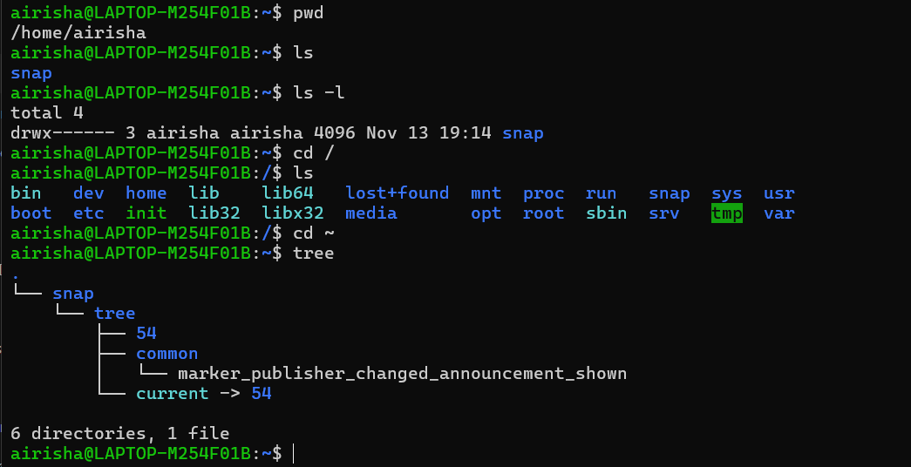
File & Directory Management
These commands help create, rename, copy, and delete files and folders.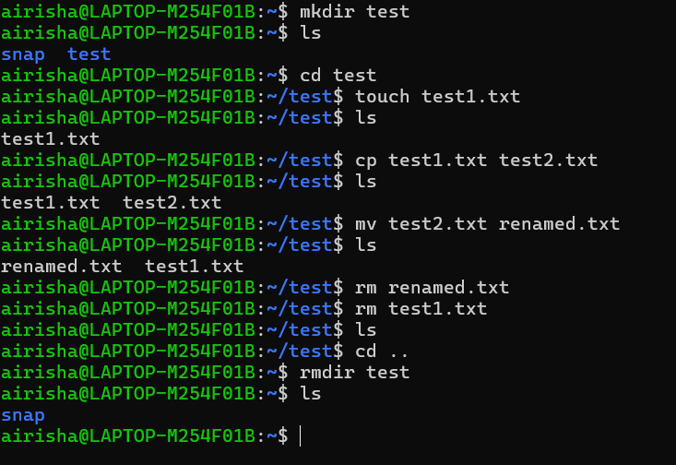

Permissions Management
Permission commands ensure network safety in linux. 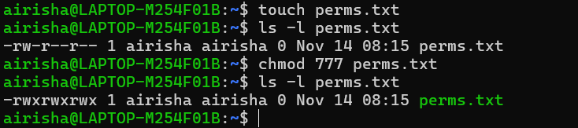
Process Monitoring
Using ps and top shows how Linux handles running tasks.
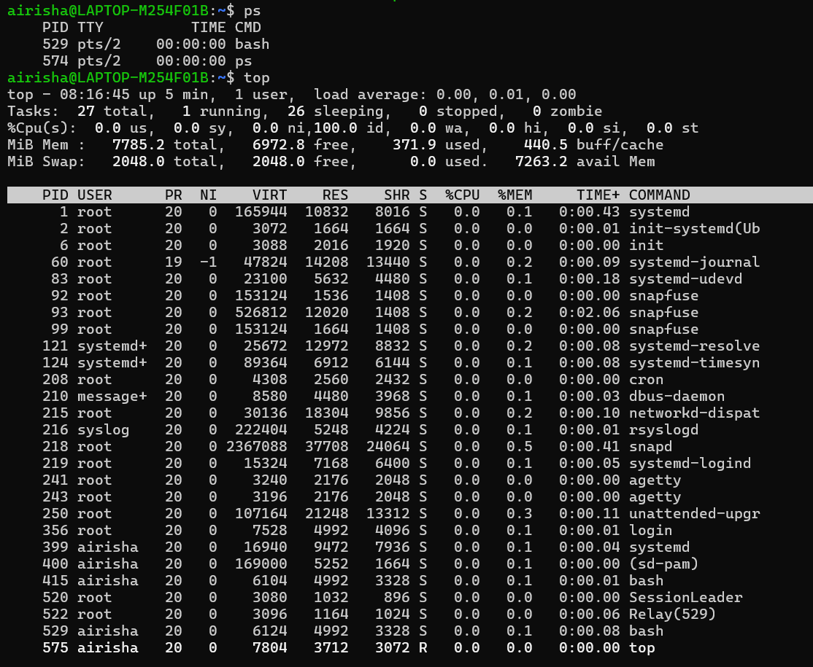

Networking Tools
Commands like ping and ip tested network connectivity and system status.

4. Shell Scripts
Three shell scripts were created to automate simple tasks.

Script 1: Backup Script
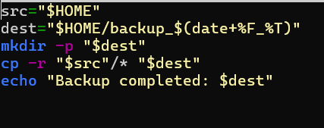
This script creates a timestamped backup of my home directory.
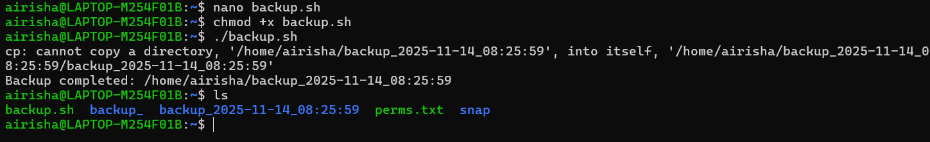

Script 2: CPU & Memory Monitor
This script enters CPU/memory usage every 10 seconds into a file.
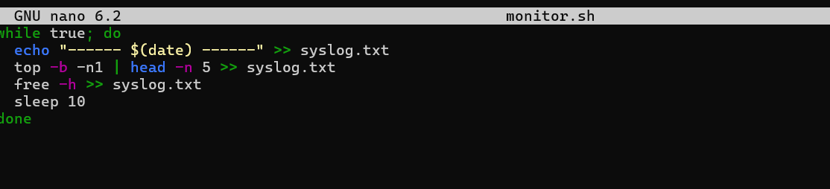
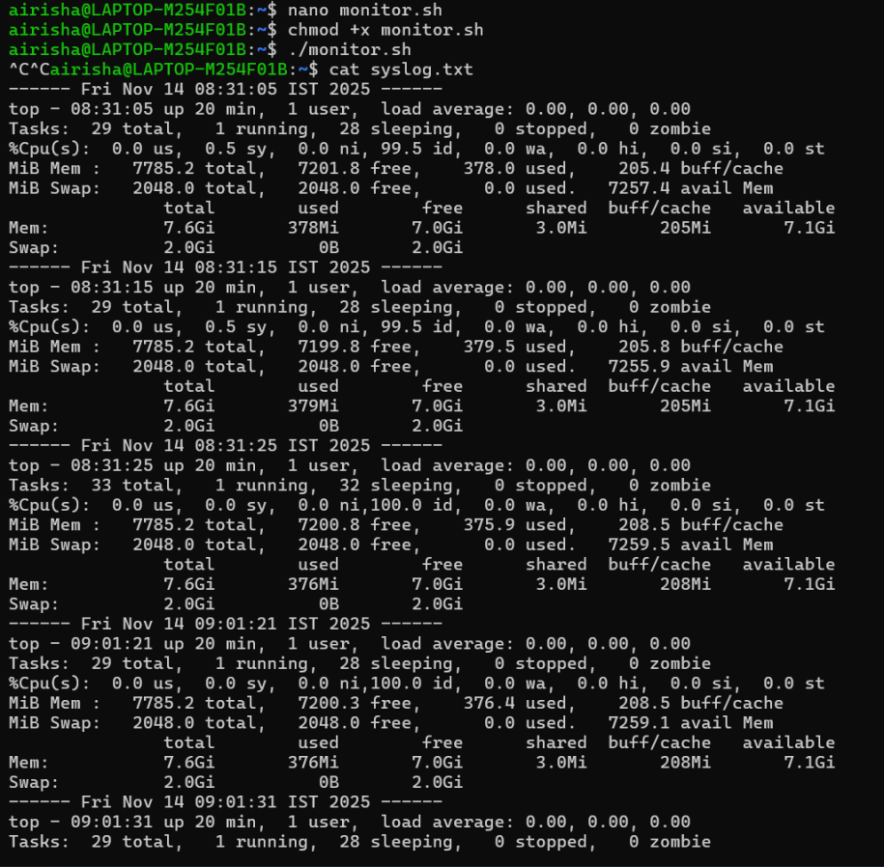

Script 3: Automated File Downloader
This script downloads a file directly into a designated folder.
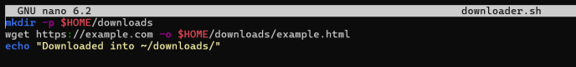
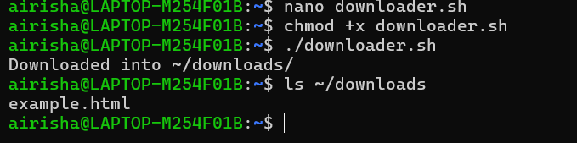

5. GitHub Repository
A github repository was created for the submission.
Repository Name: linux-shell-assignment
Files Uploaded:
- All shell scripts (.sh)
- syslog.txt
- README.md
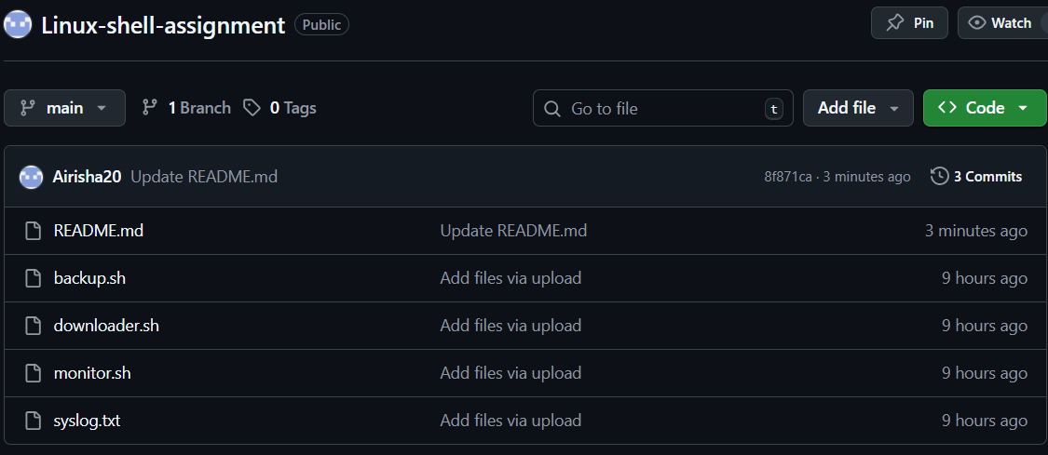
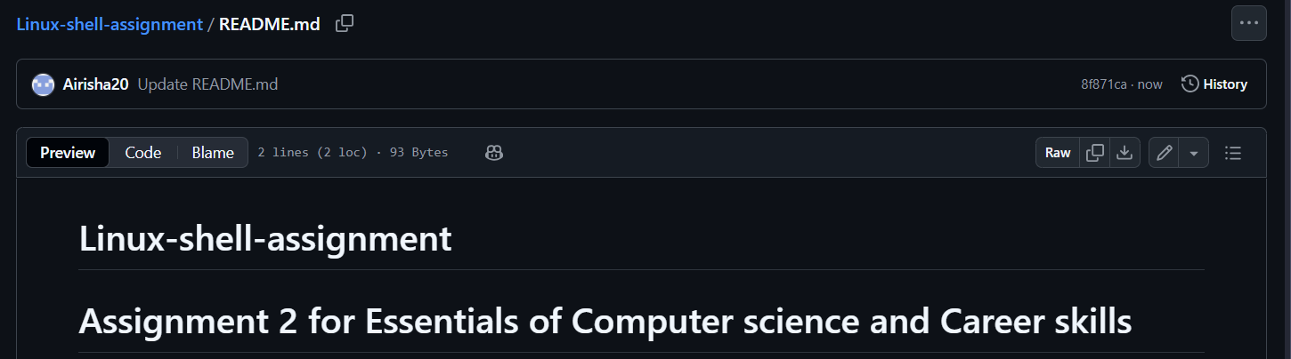

6. Reflection
The completion of this assignment gave a clearer understanding of Linux-based systems and their practical applications. Working with the command-line interface, executing system-level operations, and developing shell scripts showed how tasks can be automated and managed efficiently within a Linux environment.
Overall, the assignment improved technical competency in Linux navigation, command usage, scripting, and version control practices. These skills are essential in various domains, including system administration, cloud computing, DevOps, and general software development.

